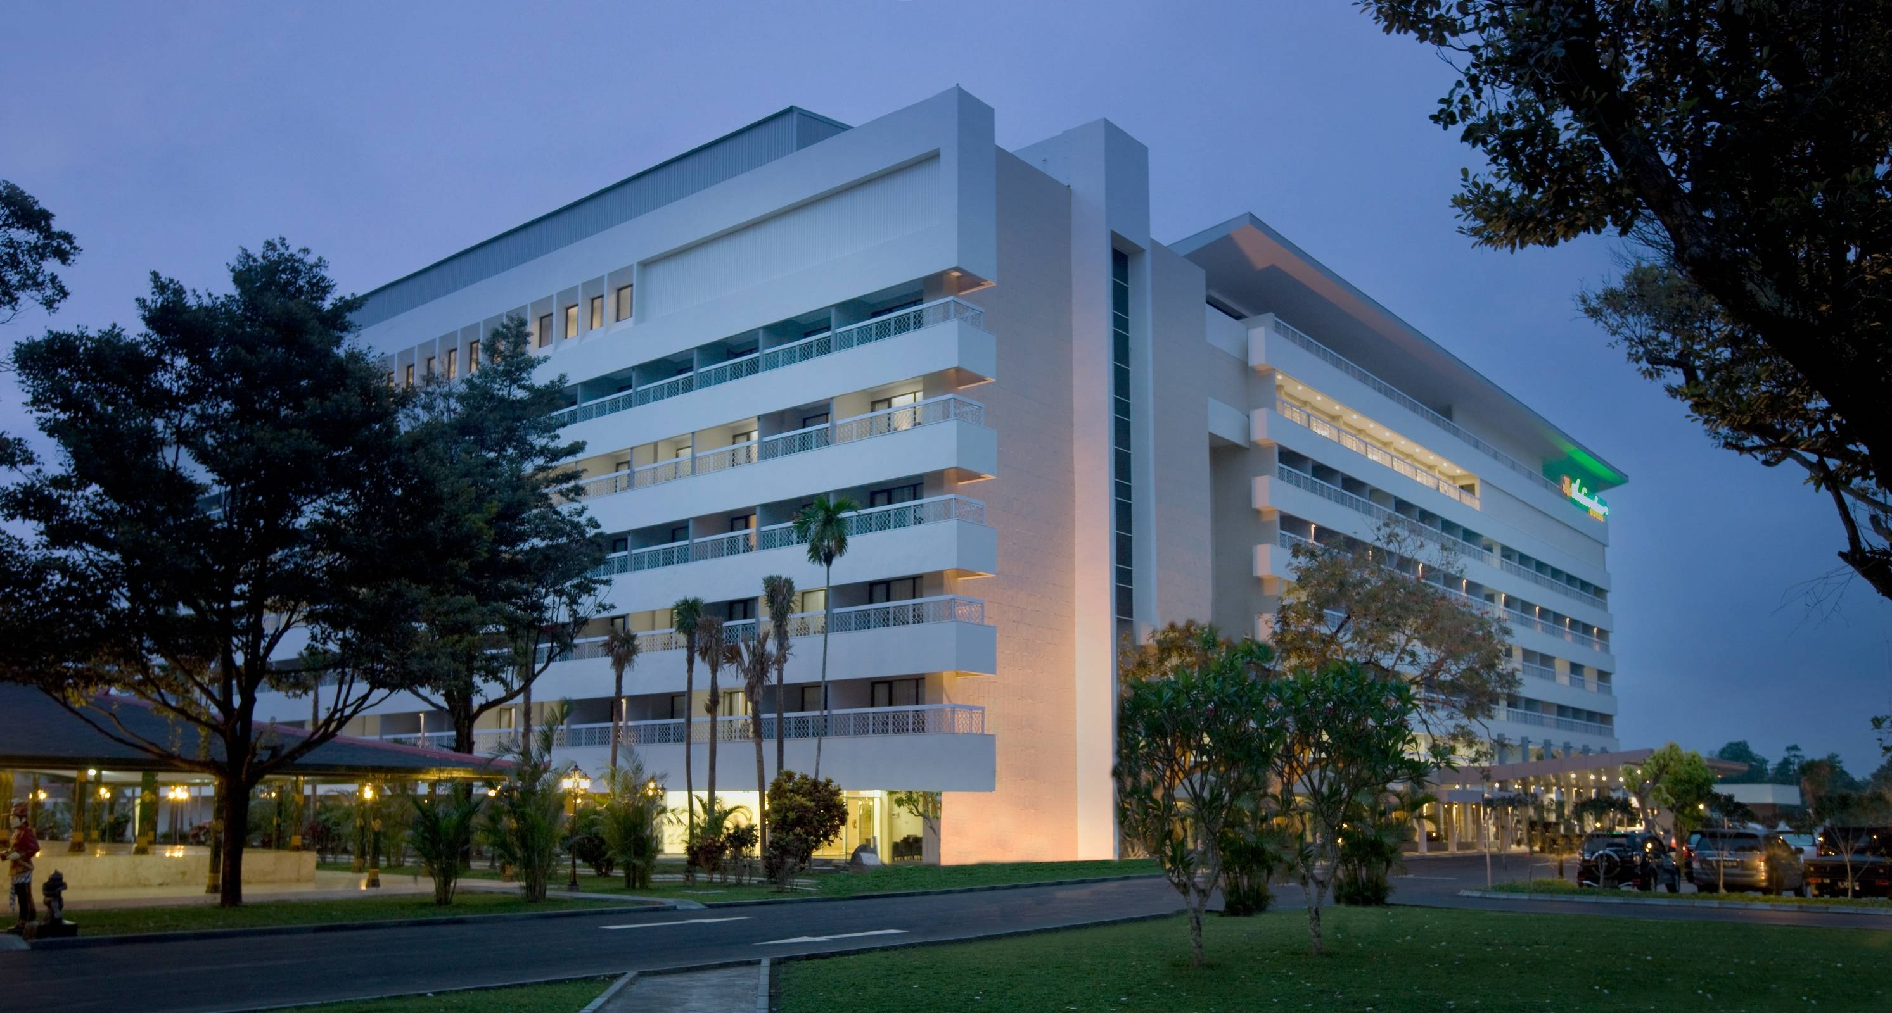

International Council for Education of
People with Visual Impairment

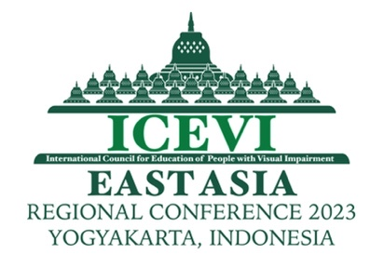
East Asia Regional Conference

Reasonable Accommodation and Accessibility in Education of Children with Visual Impairment

Organized by
ICEVI INDONESIA NETWORK

VENUE OF CONFERENCE
Hotel Royal Ambarrukmo, Yogyakarta, Indonesia

18-21 September, 2023

ICEVI
International Council for Education of People with Visual Impairment (ICEVI) is a global association of individuals and organizations that promotes equal access to appropriate education for all visually impaired children and youth so that they may achieve their full potential. For more information on ICEVI, visit the website at www.icevi.org

East Asia Regional Conference
Facilitating successful inclusion of students with visual impairment is one of the objectives of education in the blindness sector. Though there are many parameters contributing to successful inclusion, reasonable accommodation and accessibility are vital ingredients as strongly mandated by the United Nations Convention on the Rights of Persons with Disabilities (UNCRPD). Though many students and institutions working for inclusion face challenges in this area, it is also true that there are good practices around the world supporting effective inclusion through strategies addressing reasonable accommodation and accessibility.

The East Asia region, through this regional conference will be deliberating on the challenges and showcase good practices. The region had also demonstrated various strategies of accommodation and accessibility in terms of devices, learning environment, instructional materials and therefore, the presentations to be made by practitioners will be of great value for the participants of the conference.

Theme
“Reasonable Accommodation and Accessibility in Education of Children with Visual Impairment.”

The conference theme will be discussed in the light of Global perspectives on education for all, Legislations, Access, Training and Resources and the plenary sessions will focus on the following main topics.
- Reasonable accommodation and accessibility in education for students with visual disability
- Employment strategy in blindness sector - Experiences of ICEVI Higher Education Project in South East Asia
- Role of Technology in the education and employment of people with visual impairment
- Development of youth with visual impairment
- Role of parents and organisations of people with disabilities in the education, employment and advocacy of people with visual impairment

Focus on Youth Movement: There will be an exclusive plenary session of Youth with Visual Impairment from the Higher Education project of ICEVI discussing the barriers and strategies adopted to overcome those in education as well as in the employment avenues.
Block these dates and await further information on Registration Fee, Call for Abstracts, etc.
Welcome to the East Asia region for a fruitful conference.

Contact Persons:

Sri Soedarsono
Chairperson
ICEVI Indonesia Network
RSKG Habibie, Jl Tubagus Ismail Raya No 46,Bandung,
INDONESIA
Email : indonesia.icevi@yahoo.co.id

Aria Indrawati
President, ICEVI East Asia region
President, Pertuni (The Indonesian Blind Association)
Jl Kramat Sentiong No. 57 A, Jakarta
INDONESIA
E-mail : aria.indrawati@gmail.com

MNG Mani
Chief Executive Officer, ICEVI
ICEVI Secretariat
3, Professors’ Colony, SRKV Post
Coimbatore – 641 020
Tamil Nadu
INDIA
E-mail : ceo201922@gmail.com

